5.45: a) The magnitude of the force F is given to be equal to 3.8w. “Level flight” means that the net vertical force is zero, so 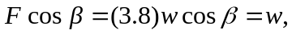, and 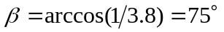.
(b) The angle does not depend on speed.

